**Conversion Between Spectral Wavenumber and Spectral Wavelength**

You have been given the following spectral data (in wavenumber ) and need to convert it to a spectral radiance (in wavelength  in units of m) so you can use it in your radiometric calculations. The spectral data was collected during the day (around 1pm) at an altitude of 2 km from a 50% Lambertian panel with an imaging spectrometer. This is one pixel from that spectrometer.

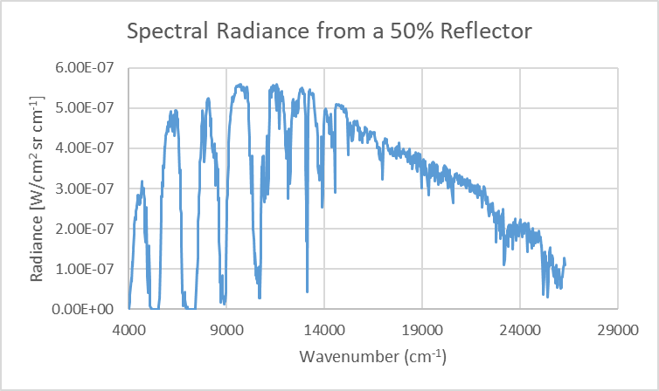

1. Derive a relationship or conversion factor to go from [W/cm2 sr cm-1] to [W/m2 sr m]. Show and illustrate all steps in your derivation.
2. Use this conversion factor to convert and **plot your new radiance data**.

Hint: The amount of radiance within a spectral interval is the same regardless of the unit of the interval as long as the intervals are equivalent.

That is L()d [W/m2 sr cm-1][cm-1] must equal L()d [W/m2 sr m][m] for the same wavelength/wavenumber center position, i.e., 0 [m] = 10,000/ [cm-1].

**Hand in your derivation and your plot of spectral radiance.**

**DO NOT simply hand in an Excel sheet with all your numbers in it (and a plot(s)). Plots should be coupled with your derivation.**